some problem solution

# calculating sums

Q : *f*(*n*) =  - 1 + 2 - 3 + .. + ( - 1)*nn*

long long n;

while(scanf("%lld", &n)==1)

if(n%2==0) {

n= (n/2);

printf("%lld\n", n);

}

Else {

n = ((n+1)/2)*(-1);

printf("%lld\n", n);

}

# prime and next prime

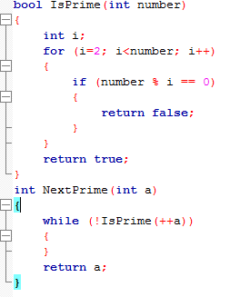

# Quick sort using std lib

